**RAJALAKSHMI ENGINEERING COLLEGE**

An AUTONOMOUS institution Affiliated to ANNA UNIVERSITY, Chennai

**Bike Spare Management System**

**LAB RECORD**

**CS19442 – SOFTWARE ENGINEERING CONCEPTS**

|  |  |  |
| --- | --- | --- |
| Submitted | by |  |
| MANICK VISHAL |  | 220701158 |
| MANIKANDAN |  | 220701159 |
| MANIMOZHI I |  | 220701160 |
| MANOJ |  | 220701161 |
| MARIA |  | 220701162 |
| MERWIN |  | 220701163 |

**TABLE OF CONTENT**

**CHAPTER TITLE**

* **OVERVIEW OF THE PROJECT**
* PROBLEM STATEMENT
* DATA
* BENEFITS TO THE USERS
* KEY COMPONENTS
* IMPORTANT FEATURES
* **BUSINESS ARCHITECTURE**
* CURRENT PROCESS
* PERSONAS
* BUSINESS PROBLEM
* **REQUIREMENT AS USER STORY**
* FUNCTIONAL REQUIREMENTS
* NON-FUNCTIONAL REQUIREMENTS
* USER STORIES
* POKER PLANNING ESTIMATES
* **UML DIAGRAM**
* ARCHITECTURE DIAGRAM
* CLASS DIAGRAM
* SEQUENCE DIAGRAM
* **TEST STRATEGY**
* TEST PLANS
* TEST CASES
* **DEPLOYMENT ARCHITECTURE**

**CHAPTER 1**

**OVERVIEW OF THE PROJECT**

**Problem Statement:**

The primary challenge that the "Bike Spare Management System" project addresses is the efficient and accurate management of bike spare parts inventory. Maintaining optimal inventory levels for bike spare parts is crucial for retailers, repair shops, and distributors. Overstocking can lead to increased storage costs and potential obsolescence, while understocking can result in missed sales opportunities and decreased customer satisfaction. Balancing these factors is essential for smooth operations and profitability.

**Data:**

The success of the "Bike Spare Management System" relies heavily on comprehensive data related to bike spare parts. This data can be sourced from various places such as supplier databases, sales records, and inventory logs. Key features include:

- Part Identification: Unique identifiers for each spare part to ensure precise tracking and management.

- Stock Levels: Current inventory levels to monitor availability.

- Sales Data:Historical sales data to predict future demand and identify trends.

- Supplier Information: Details about suppliers, including lead times and order quantities.

- Pricing Information: Cost and pricing details to optimize pricing strategies.

- Order History: Records of past orders to analyze purchasing patterns and supplier performance.

A diverse and comprehensive dataset is critical for developing an accurate and robust inventory management model.

**Benefits to Users:**

Implementing the "Bike Spare Management System" can provide several benefits to users:

**1. Optimized Inventory Levels:**By accurately predicting demand for spare parts, users can maintain optimal stock levels. This prevents overstocking and understocking, leading to cost savings and increased sales.

**2. Efficient Decision Making:**A reliable prediction model enables users to make quick and informed decisions about inventory management. It reduces reliance on guesswork and ensures data-driven decision-making.

**3. Improved Supplier Management:**The system can help users identify the best suppliers based on performance metrics and lead times. This can streamline procurement processes and improve relationships with suppliers.

**4. Market Trends:** Over time, the prediction model can help users understand market trends and the factors that most significantly impact demand for bike spare parts. This insight can be useful for strategic planning and identifying emerging opportunities.

**5. Personalized Recommendations:**If integrated with a user’s preferences, the system can provide personalized recommendations. For example, if a user frequently purchases certain types of spare parts, the system could prioritize these in stock replenishment and provide suggestions for related items. This enhances the user experience and can lead to increased customer loyalty.

**Conclusion:**

The "Bike Spare Management System" leverages machine learning to transform the way bike spare parts are managed. By addressing the key challenges of inventory management, this system provides a comprehensive solution that benefits retailers, repair shops, and distributors. With optimized stock levels, efficient decision-making, improved supplier management, insights into market trends, and personalized recommendations, this system is poised to enhance operational efficiency and drive business growth.

**Key Components**:

1. Inventory Tracking:

- Real-time monitoring of bike spare parts inventory.

- Track stock levels, locations, and movement of each spare part.

2. Automated Reordering:

- Set reorder points and automatically generate purchase orders when stock levels fall below threshold.

- Integration with suppliers for seamless procurement.

3. Part Identification:

- Assign unique identifiers to each bike spare part for precise tracking and management.

- Barcode or QR code scanning for quick identification.

4. Sales and Demand Forecasting:

- Analyze historical sales data to predict future demand for bike spare parts.

- Optimize inventory levels to meet customer demand while minimizing excess stock.

5. Supplier Management:

- Maintain a database of suppliers with contact details, lead times, and pricing information.

- Evaluate supplier performance and negotiate favorable terms.

6. Reporting and Analytics:

- Generate reports on inventory levels, sales trends, and stock turnover.

- Analyze data to identify opportunities for cost savings and process improvements.

7. User Access Control:

- Role-based access control to restrict system access based on user roles and responsibilities.

- Ensure data security and compliance with privacy regulations.

8. Integration with POS and ERP Systems:

- Seamlessly integrate with Point of Sale (POS) systems to synchronize sales data with inventory.

- Connect with Enterprise Resource Planning (ERP) systems for holistic business management.

9. Alerts and Notifications:

- Receive alerts for low stock levels, overdue orders, and other inventory-related issues.

- Notifications for upcoming maintenance tasks or warranty expirations.

10. Mobile Accessibility:

- Access inventory information and perform tasks from mobile devices for on-the-go management.

- Receive push notifications for important updates or alerts.

**IMPORTANT FEATURES**

1. Real-time Inventory Tracking:

- Monitor bike spare parts inventory levels and movements in real-time.

- Ensure accurate stock counts and prevent stockouts or overstock situations.

2. Automated Reordering:

- Set up automated triggers for reordering when inventory levels reach predefined thresholds.

- Streamline procurement processes and minimize manual intervention.

3. Part Identification and Barcoding:

- Assign unique identifiers or barcodes to each bike spare part for easy tracking and management.

- Expedite inventory management tasks with quick scanning capabilities.

4. Sales and Demand Forecasting:

- Utilize historical sales data and demand forecasting algorithms to predict future demand.

- Optimize inventory levels to meet customer needs while minimizing excess inventory costs.

5. Supplier Management:

- Maintain a database of suppliers with detailed information such as contact details, lead times, and pricing.

- Evaluate supplier performance and establish strong partnerships for reliable inventory replenishment.

6. Reporting and Analytics:

- Generate comprehensive reports and analytics on inventory levels, turnover rates, and stock movement.

- Gain insights into inventory performance and make data-driven decisions for inventory optimization.

7. User Access Control:

- Implement role-based access control to restrict system access based on user roles and responsibilities.

- Ensure data security and compliance with privacy regulations.

8. Integration with POS Systems:

- Seamlessly integrate with Point of Sale (POS) systems to synchronize sales data with inventory levels.

- Enable automatic updates to inventory records following sales transactions.

9. Alerts and Notifications:

- Receive alerts for low stock levels, pending orders, or inventory discrepancies.

- Stay informed about critical inventory-related events to take timely actions.

10. Mobile Accessibility:

- Access inventory information and perform inventory tasks from mobile devices.

- Enable flexibility and on-the-go management for inventory control.

11. Batch and Serial Number Tracking:

- Track batches or serial numbers for bike spare parts to facilitate traceability and recall management.

- Ensure product quality control and compliance with regulatory requirements.

12. Multi-location Support:

- Manage inventory across multiple warehouse locations or retail outlets.

- Transfer stock between locations and maintain accurate inventory records.

These important features collectively empower bike spare inventory management systems to optimize inventory levels, streamline operations, and enhance overall efficiency in the supply chain..

**CHAPTER 2 BUSINESS ARCHITECTURE**

**CURRENT PROCESS**

Currently, the bike spare inventory management system relies on manual processes and basic digital tools. Inventory tracking is predominantly conducted through spreadsheets or paper-based logs, with staff manually updating stock counts and monitoring levels. Ordering and replenishment are initiated through visual inspections or periodic reviews, lacking automated triggers for reordering. Data analysis is limited to rudimentary calculations, and supplier management involves manual communication for placing orders. Integration with other business processes is minimal, resulting in data silos and inefficiencies. Reporting is basic, with manual compilation of data, and record-keeping is primarily manual. Overall, the system lacks automation and integration, hindering efficiency and decision-making capabilities.

**PERSONS:**

**1. Retail Manager (Alex):**

- Alex manages a bike retail store and is responsible for overseeing inventory management.

- Their main goal is to ensure that the store has sufficient stock of bike spare parts to meet customer demand while minimizing excess inventory.

- Alex needs a system that provides real-time inventory tracking, automated reordering, and comprehensive reporting to optimize stock levels and streamline operations.

**2. Mechanic (Sarah):**

- Sarah works as a mechanic at a bike repair shop and frequently needs to access bike spare parts for repairs.

- Their primary concern is having quick and easy access to the right spare parts when needed to minimize repair turnaround time.

- Sarah requires a system that provides accurate inventory information, part identification, and streamlined ordering processes to efficiently manage repairs.

**3. Procurement Officer (Chris):**

- Chris is responsible for procuring bike spare parts for a distributor or manufacturer.

- Their main objective is to source high-quality parts from reliable suppliers at competitive prices and ensure timely delivery.

- Chris needs a system that facilitates supplier management, automates procurement processes, and provides insights into supplier performance and pricing trends.

**4. Warehouse Manager (Emily):**

**-** Emily oversees the warehouse where bike spare parts are stored and managed.

- Their primary focus is on maintaining organized inventory storage, optimizing warehouse layout, and managing stock movements.

- Emily requires a system that offers barcode scanning, inventory tracking, and warehouse management features to efficiently manage stock levels and warehouse operations.

**BUSINESS PROBLEM**

Several business problems can arise in bike spare inventory management systems, including:

**1. Stockouts and Overstocking:** Inaccurate inventory tracking or inefficient ordering processes can lead to stockouts, where essential bike spare parts are unavailable when needed, or overstocking, resulting in excess inventory and increased storage costs.

**2. Manual Processes and Errors:** Reliance on manual inventory management processes increases the likelihood of errors in data entry, stock counts, and order fulfillment, leading to inventory discrepancies and operational inefficiencies.

**3. Poor Demand Forecasting:** Inadequate analysis of sales data and market trends can result in inaccurate demand forecasting, leading to understocking or overstocking of bike spare parts, which can impact customer satisfaction and revenue.

**4. Inefficient Supplier Management:** Lack of visibility into supplier performance, long lead times, and unreliable deliveries can disrupt inventory replenishment and increase procurement costs.

**5. Lack of Integration:** Disconnected systems and siloed data prevent seamless integration with other business processes such as sales, procurement, and accounting, leading to data duplication, inefficiencies, and missed opportunities for optimization.

**6. Limited Reporting and Analytics:** Basic reporting capabilities and lack of actionable insights into inventory performance hinder strategic decision-making and optimization of inventory levels and processes.

**7. Ineffective Warehouse Management:** Poor organization of warehouse layout, inefficient stock movements, and manual handling processes can lead to delays in order fulfillment, increased labor costs, and decreased productivity**.**

**CHAPTER 3**

**REQUIREMENTS AS USER STORY**

**FUNCTIONAL REQUIREMENTS**

Functional requirements define the basic system behavior. In other words, they specify what the system should do. For the “Bike Spare Management System” project, the functional requirements could be:

* **User Management:**

User Authentication: Secure login and logout functionalities.

User Roles: Different roles (admin, manager, staff) with varying levels of access and permissions.

* **Inventory Management:**

Spare Parts Catalog: Detailed catalog of all spare parts including part numbers, descriptions, categories, and images.

Stock Management: Track stock levels, set minimum stock thresholds, and generate alerts for low stock.

* **Purchasing Management:**

Purchase Orders: Create, manage, and track purchase orders from suppliers.

Supplier Management: Maintain a database of suppliers, including contact details and historical purchase data.

Receiving Shipments: Record the receipt of spare parts and update inventory accordingly.

* **Sales Management:**

Sales Orders: Create and manage sales orders from customers.

Customer Management: Maintain a database of customers, including contact details and purchase history.

Billing and Invoicing: Generate invoices and process payments.

* **Reporting and Analytics:**

Inventory Reports: Generate reports on current stock levels, low stock items, and inventory valuation.

Sales Reports: Generate reports on sales performance, best-selling items, and revenue trends.

Purchase Reports: Generate reports on purchasing trends, supplier performance, and costs.

* **Notification and Alerts:**

Low Stock Alerts: Automatic notifications for items that fall below the minimum stock level.

Expiry Notifications: Alerts for spare parts with expiration dates.

Order Status Updates: Notifications for order status changes (e.g., order shipped, order delivered).

* **Backup and Security:**

Data Backup: Regular backup of inventory data to prevent data loss.

Data Security: Implement security measures to protect sensitive data from unauthorized access.

* **User Interface:**

Dashboard: A user-friendly dashboard that provides an overview of inventory status, recent transactions, and alerts.

Mobile Access: A mobile-friendly interface or app for managing inventory on the go.

**NON-FUNCTIONAL REQUIREMENTS**

Non-functional requirements define the system’s properties or qualities, such as performance, security, usability, etc. For the “Bike Spare Inventory Management” project, the non- functional requirements could be:

* **Performance:** The system should respond to user queries within 2 seconds. Inventory updates and transactions should be processed in real-time or within 1 second.
* **Usability:** The system should have an intuitive and user-friendly interface, minimizing the learning curve.Comprehensive user manuals and help guides should be available.
* **Security:** The system should use strong authentication mechanisms (e.g., multi-factor authentication).Sensitive data should be encrypted both at rest and in transit.The system should log all access and changes to inventory data for auditing purposes.
* **Scalability:** The system should support adding more servers to handle increased load.The system should efficiently manage growing amounts of data without performance issues.
* **Reliability:**  The system should be available 99.9% of the time, ensuring minimal downtime.Automated daily backups should be performed to prevent data loss.

**USER STORIES**

* As an inventory manager, I want to add new spare parts to the inventory so that I can keep the stock updated with the latest products.
* As a warehouse staff member, I want to update the quantity of spare parts in the inventory after receiving new shipments so that the inventory reflects accurate stock levels.
* As a salesperson, I want to check the availability of a specific spare part quickly so that I can inform customers about stock status.
* As a customer service representative, I want to generate an inventory report showing current stock levels and low stock items so that I can plan reordering.
* As a supplier, I want to receive notifications when the stock level of a specific spare part is low so that I can prepare for restocking.
* As a system administrator, I want to manage user roles and permissions so that only authorized personnel can perform critical inventory operations.
* As an inventory auditor, I want to track and view the history of inventory adjustments so that I can ensure all changes are properly documented.
* As a retail store manager, I want to transfer spare parts between different store locations so that I can balance inventory across stores.
* As a mechanic, I want to reserve specific spare parts for upcoming repair jobs so that I can ensure availability when needed.
* As a business analyst, I want to analyze sales and inventory trends over time so that I can make data-driven decisions on stocking and purchasing.

**POKER PLANNING ESTIMATIONS**

Poker planning, also known as Planning Poker, is a consensus-based estimation technique used in Agile project management. In this technique, team members estimate the effort required to complete user stories by assigning point values. Below, I will provide poker planning estimates for the Bike Spare Inventory Management System user stories, classified into easy, medium, and hard based on their complexity and effort required.

**Easy**

Inventory Manager: Add New Spare Parts.

Salesperson: Check Availability.

System Administrator: Manage User Roles and Permissions.

**Medium**

Warehouse Staff: Update Quantity After Receiving Shipments.

Customer Service Representative: Generate Inventory Report.

Inventory Auditor: Track and View Inventory Adjustment History.

Mechanic: Reserve Spare Parts for Repair Jobs.

**Hard**

Supplier: Receive Low Stock Notifications.

Retail Store Manager: Transfer Spare Parts Between Store Locations.

Business Analyst: Analyze Sales and Inventory Trends.

These estimates are based on typical complexities and effort required for such tasks. However, the final estimates should be determined by the development team through the actual poker planning session, taking into account their expertise, experiences, and the specific context of the project.

**CHAPTE-4 UML DIAGRAM**

**ARCHITECTURE DIAGRAM**

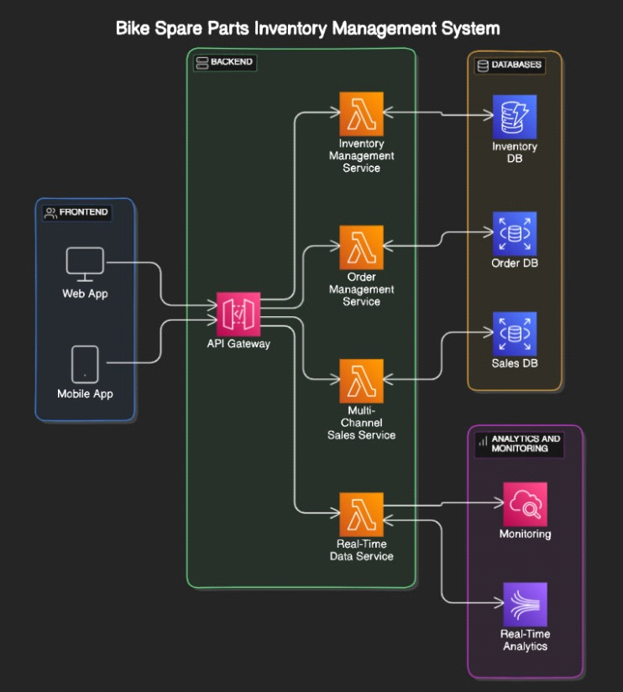

**CLASS DIAGRAM**

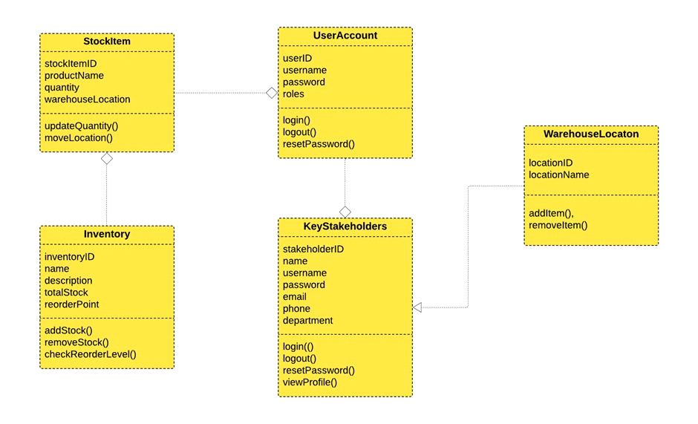

**SEQUENCE DIAGRAM**

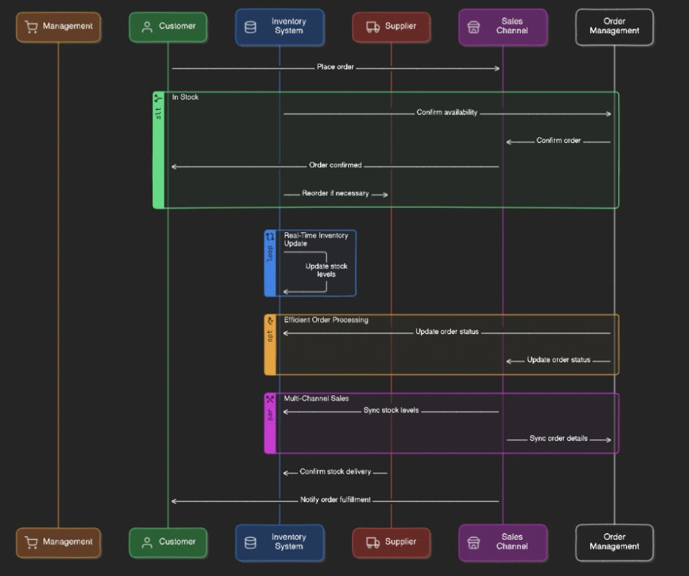

**CHAPTER-5 TEST STRATEGY**

**Test Plans**

A test plan for the “Bike Spare Management System” project could include the following elements:

**Introduction:**

* The purpose of this test plan is to define the strategies, objectives, resources, schedule, and scope of testing activities for the Bike Spare Inventory Management System to ensure it meets the requirements and functions correctly.
* **Test Items:** A list of features to be tested.
* **Features to be Tested:** Detailed descriptions of the system features to be tested.
* **Features not to be Tested:** Detailed descriptions of the system features not to be tested.
* **Approach:** The overall strategy and methodology that will be used to conduct the tests.
* **Item Pass/Fail Criteria:** The criteria that will be used to determine whether a test item has passed or failed.
* **Test Deliverables:** Test summary report,Defect logs,Test case documentation,UAT sign-off.
* **Testing Tasks:** A list of tasks to be performed during testing.
* **Environmental Needs:** Any necessary infrastructure, tools, or equipment.
* **Responsibilities:** The roles and responsibilities of each member of the testing team.
* **Schedule:** Test Planning: [Start Date] to [End Date].
* **Risks and Contingencies:** Potential risks and Mitigation Strategies.

**Test Cases**

Here are some example test cases for the user stories mentioned earlier:

* **User Story 1 – Inventory Manager:**
* As an inventory manager, I want to add new spare parts to the inventory so that I can keep the stock updated with the latest products.
* Test Case ID:

Title: Add New Spare Parts

Preconditions: User is logged in as an Inventory Manager.

Expected Result: New spare part is added and visible in the inventory list.

* **User Story 2 – Warehouse Staff:**
* As a warehouse staff member, I want to update the quantity of spare parts in the inventory after receiving new shipments so that the inventory reflects accurate stock levels.

Test Case ID:

Title: Update Quantity After Receiving Shipments

Preconditions: User is logged in as Warehouse Staff.

Expected Result: Spare part quantity is updated and accurately reflected in the inventory.

* **User Story 3 – Salesperson:**
* As a salesperson, I want to check the availability of a specific spare part quickly so that I can inform customers about stock status.

Title: Check Availability of Spare Parts

Preconditions: User is logged in as a Salesperson.

Expected Result: The system displays the current stock level of the searched spare part.

* **User Story 4 – Customer Service Representative:**
* As a customer service representative, I want to generate an inventory report showing current stock levels and low stock items so that I can plan reordering.

Title: Generate Inventory Report

Preconditions: User is logged in as a Customer Service Representative.

Expected Result: Inventory report is generated with current stock levels and highlights low stock items.

* **User Story 5 – Supplier:**
* As a supplier, I want to receive notifications when the stock level of a specific spare part is low so that I can prepare for restocking.

Title: Receive Low Stock Notifications

Preconditions: Supplier's contact details are set up in the system.

Expected Result: Supplier receives a notification (email/SMS) about the low stock.

**CHAPTER 6**

**DEPLOYMENT ARCHITECTURE**

Creating a deployment architecture for the Bike Spare Inventory Management System involves defining the structure and components needed to deploy and run the system efficiently. Here’s a detailed deployment architecture:

* **OVER VIEW:** The Bike Spare Inventory Management System will be deployed in a cloud-based environment to ensure scalability, reliability, and accessibility. The architecture will leverage modern web technologies and cloud services to provide a robust and efficient system.
* **Components:** Web Server, Application Server,Database server, Load Balancer,CDN,Authentication and Authorization,Monitoring and Logging,Backup and Recovery.
* **Feature Engineering:** This involves creating new features from existing ones to improve the model’s predictive power. For example, creating a feature that represents the age of a house from the year it was built, or creating a feature that represents the proximity to amenities from the location data.
* **Model Training:** This is where you select a machine learning algorithm and

train it on your pre-processed data. You could use various regression models like Linear Regression, Decision Tree Regression, Random Forest Regression, etc.

* **Model Evaluation:** After training the model, you need to evaluate its performance. You could use metrics like Mean Absolute Error (MAE), Mean Squared Error (MSE), or Root Mean Squared Error (RMSE) for evaluation.
* **Model Optimization:** Based on the evaluation, you might need to optimize your model by tuning hyperparameters or using different regression models.
* **Model Deployment:** Once you are satisfied with your model’s performance, you can deploy it to a web server or create a user-friendly interface where users can input the features of a house and get a predicted price.
* **Monitoring and Updating:** After deployment, it’s important to monitor the model’s performance and update it as new data becomes available.

**ARCHITECTURE DIAGRAM:**



* **Conclusion**

This deployment architecture ensures that the Bike Spare Inventory Management System is scalable, reliable, and secure, providing a robust solution for managing bike spare parts inventory effectively. The use of cloud services allows for flexible resource management and quick scaling as demand grows.